Once Upon a Time…
Sue Spiller
Sobus CEO 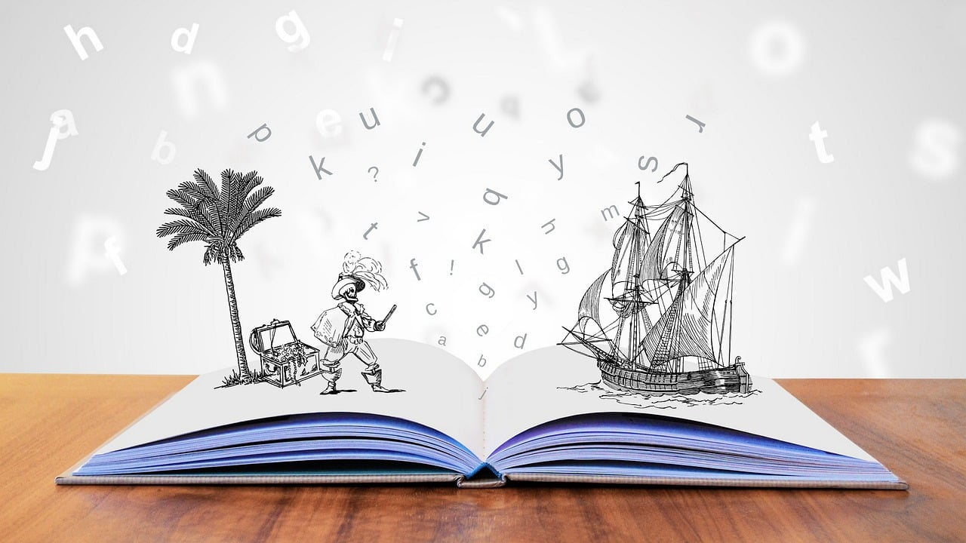

National Storytelling Week runs from 30th January to 6th February and is a celebration of the art of storytelling and the power of stories to connect, entertain, and inspire. During this week, people of all ages come together to share and enjoy stories in various forms, from traditional oral tales to modern narratives. It’s a time to appreciate the rich tapestry of human storytelling and its significance in our lives.

National Storytelling Week is an annual event that encourages individuals and communities to embrace the tradition of storytelling. It’s a time to celebrate the diverse ways in which stories are told, whether through spoken word, written narratives, theatre, film, or other creative mediums. This week provides a platform for storytellers, both amateur and professional, to showcase their talents and engage audiences with captivating tales.

A good read
We have a fantastic organisation in Hammersmith & Fulham that’s all about reading and storytelling – the Doorstep Library Network.

“Doorstep Library is a community-focused literacy charity dedicated to bringing the magic of books and the joy of reading directly into the homes of children across London and beyond who need our support. For us the ‘happy ever after’ is when we know the power of literacy and the joy of reading for pleasure are helping a child change their own story for good.”

Doorstep Library recruits and trains reading volunteers to go into disadvantaged areas of London and beyond, to help introduce young children to the pleasure and benefits of reading.

Their unique home-based service means they are there either in person or online, finding the most appropriate books for every child they visit and building a relationship with the whole family. Equipped with two little reading stools and backpacks brimming with books, or with parcels of books sent directly to families through the post, their volunteers are right there ready to help and inspire.

Doorstep Library use books to fuel children’s natural love of stories, fire their imaginations, and encourage their appreciation of reading. Their goal is to help each child develop the self-confidence and essential skills they need to reach their full potential. Their volunteers visit families in pairs to run reading sessions every week in term-time. Sessions take place on the same evening each week and last approximately 20 minutes. Parents and carers are encouraged to join the sessions and to continue to read with children after they volunteers have gone because sharing stories together improves child-parent bonds, which in turn enriches family life, leads to better literacy and enhanced life opportunities.

In many cases Doorstep Library volunteers befriend the families and are warmly welcomed into their lives. They are there to lend a listening ear, to offer support, to have a friendly chat with parents and carers. In return the volunteers are able to watch the children develop and grow in confidence. They also have the opportunity to meet and spend time with a broad and diverse range of families, as well as other volunteers.

Having reached out and established a trusted link with the family, Doorstep Library is able to help families form bonds with the wider community through our signposting of local services. Books and reading form the basis of a contract of trust – it provides a valuable platform to help forge community bonds that might otherwise be lost.

Doorstep Library reading services are completely free, child-led and flexible. There are no costs or fines for books which are lost or damaged. There is no commitment – families can choose to have a visit or not each week.

To find out more about this fantastic charity, visit: https://doorsteplibrary.org.uk/

The story of Hammersmith & Fulham
The council’s website has a fascinating section on the stories of Hammersmith & Fulham, and is where you can find a host of information on the histories of our residents and communities that has made the borough what it is today.

Hammersmith & Fulham can rightly be called one of London’s smallest boroughs with a big history and even bigger future. From its early human settlements, all manner of peoples and organisations - the Romans, kings, important figures, and 3 major football clubs (Chelsea, Fulham, and QPR) - have shaped this borough’s history. The borough’s Black history, particularly, has impacted the whole world.

This section of the council’s website aims to give you an idea of the great things that are happening and have happened in H&F: https://www.lbhf.gov.uk/celebrating-hf

However, these pages are not complete but an introduction. They can only be completed when all our stories, and your story, are included. Hopefully, you can tell us about what you think needs to be added.

Perhaps you, your family, friends, or someone you think is doing something that should be recognised will be featured here in the future. We are all part of the rich tapestry, past, present and great future of this borough.

