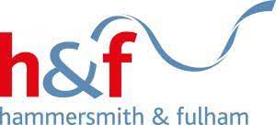

Dear Partners,

As the weather becomes colder and inflation continues to rise we are all seeing the impact the cost of living crisis has on all residents, our services and businesses. Over the past two months we have met with many of you to identify ways we can help residents and each other through this difficult time. Following our recent third sector partners workshop in October, the council has taken on board the feedback and recommendations to make changes to delivering services better for everyone.

We really value your feedback, and we are keen to continue to work with you all, building an amazing network of support and developing our innovative ways of doing things differently.
I write to invite you to join me in attending our Cost of Living Conference, where there will be an opportunity to discuss the further challenges we are facing, hear about the changes the council has made following recommendations from you, share further ideas and maximise support to as many residents as possible, and build our Alliance of Support working together.

If you are unable to attend please do encourage someone from your organisation to come in your place, so we can ensure everyone’s views and ideas are captured and so you can find out more on the changes we have made, as we continue to build support.

Date: Wednesday 30 November 2022
Time: 09:30am to 12.45pm with lunch
Venue: 3 Shortlands, Hammersmith, London, W6 8DA

Please do kindly register your attendance here: Hammersmith & Fulham Cost of Living Crisis Workshop 2022 Tickets, Wed 30 Nov 2022 at 09:30 | Eventbrite
Please do arrive from 9.30am to register. Teas and coffee will be available. As there is so much to discuss we will start the meeting at 10am and lunch will be provided.

I look forward to meeting you all.
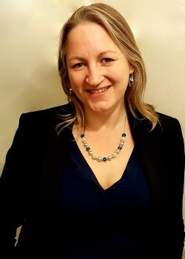
Best wishes

Rebecca

Cllr. Rebecca Harvey
Cabinet member for Social Inclusion and Community Safety

Labour
Councillor for Wendell Park Ward
Hammersmith & Fulham Council
London
W6 9JUto

