

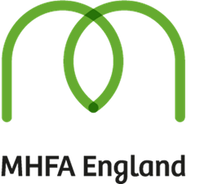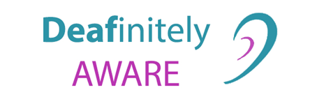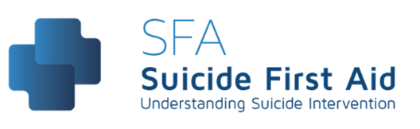

**Fully funded courses for those living in North Kensington with thanks to the Grenfell Projects Fund 2**

**Deaf Awareness: 1st August 2022 10am- 4pm**

**2-day Mental Health First Aid: 8th & 15th August 2022 10am-4:30pm**

**Suicide First Aid: 23rd Aug 9:30am-4:30pm**

**Face to Face Training in a North Kensington Venue**

**Contact Catherine to book on:** [**mhtcatherine@gmail.com**](mailto:mhtcatherine@gmail.com) **or 07809602140**

**Catherinemht.com**