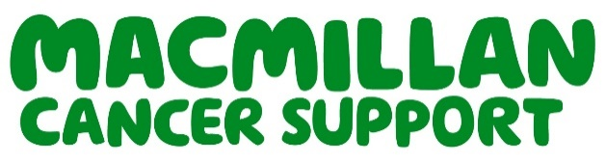

Immediate release

Hammersmith and Fulham Links Service scoops prestigious Macmillan award for going above and beyond for people living with cancer

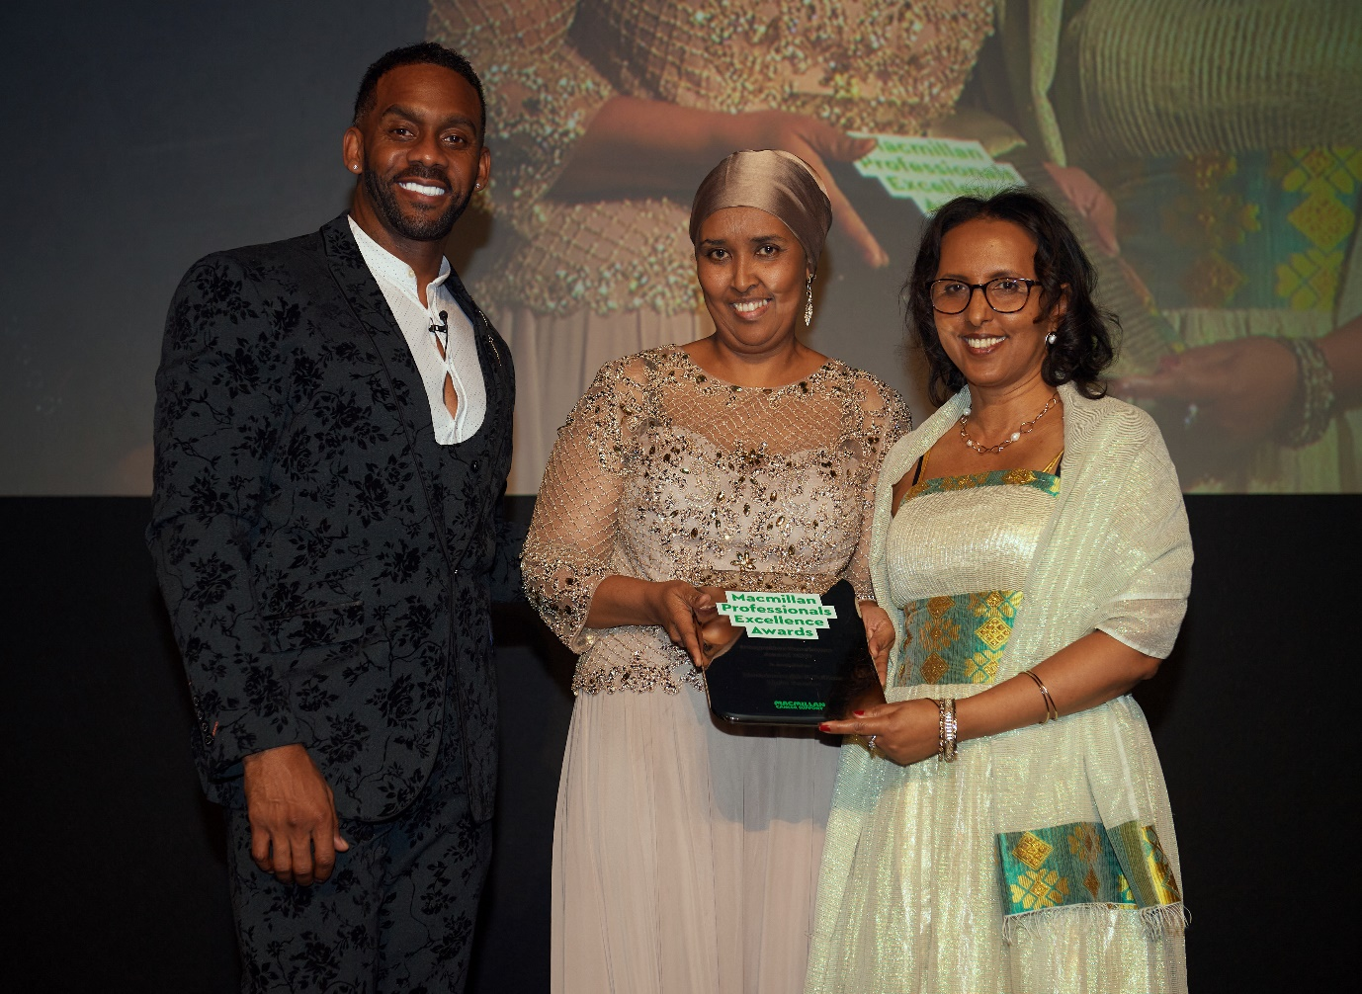
(from left to right) Richard Blackwood - Awards Host, Sacdiya Ali, Lead Macmillan Link Worker for Hammersmith and Fulham Links Service and Lily Woldesmait, Macmillan Link Worker for Hammersmith and Fulham Links Service
➢

A London-based service going above and beyond for people living with cancer in Hammersmith and Fulham has been honoured with a prestigious Macmillan award for its inspirational work to support people living with cancer within the borough.

The Hammersmith and Fulham Links Service was awarded the much-coveted Integration Excellence Award, recognising how individuals and teams have worked together to improve the coordination of services.

It also acknowledges its success enabling a ‘joined-up’ approach across all services – from GPs to hospital - a patient is likely to encounter after their diagnosis, providing a seamless experience for people living with cancer.

The dedicated 13-strong team of Link Workers support all patients with non-medical issues that impact on their health and wellbeing. The team comprises 3 link workers, five of whom were originally funded by Macmillan but are now sustainable and taking giant strides in improving the lives of people with cancer.

The annual awards recognise the incredible work of Macmillan professionals and teams up and down the country. The Hammersmith and Fulham Links Service was nominated by colleagues for their dedication to supporting people living with cancer in the area.

Sacdiya Ali, Lead Macmillan Link Worker for Hammersmith and Fulham Links Service, who accepted the award on behalf of the team says:

“This award is recognition of all the hard work the team has done over the years and especially during the last most challenging year. It is proof that coming together and working well is not only possible but also necessary. It is the only way to go forward and help people in need.

“On behalf of everyone at the Hammersmith and Fulham Links Service, we want to thank Macmillan for the honour.”

Lily Woldesmait, Macmillan Link Worker for Hammersmith and Fulham Links Service, who also accepted the award says:

“The Integration Excellence award is about joining up services to help people with cancer and that’s exactly why we are so excited that the Hammersmith and Fulham Links Service won! We are about linking up different services, organisations and professionals to make the lives of patients just a little bit easier.

“The team actively seeks out new ways to fill gaps in patients’ needs by linking up with voluntary and community services including Citizens Advice, Law Centres, Maggie’s and the Macmillan Cancer Navigator Service at Imperial College.”

Macmillan Partnership Manager for London, Yvonne Beadle says:

“The Hammersmith and Fulham Links Service is invaluable to address all patients’ non-medical needs, including people living with cancer. They help with a broad range of issues from housing disrepair to benefits, from loneliness and isolation, to mental health issues and travel to hospital appointments.

“The Macmillan Excellence Awards are an annual opportunity to show our appreciation for Macmillan professionals and services like these, who work tirelessly day in day out to make a real difference for people with cancer in London.

“The awards highlight the partnership work between Macmillan and other organisations including the Hammersmith and Fulham GP Federation, with roles usually funded thanks to the public’s generosity.

“This year that work has been more vital than ever, due to the challenges that the coronavirus pandemic has brought, and we are incredibly proud of the Hammersmith and Fulham Links Service and all our professionals, and their continued commitment to going above and beyond in their work.”

Helen Poole, Director of Integration at the Hammersmith & Fulham GP Federation, said:

“We are delighted to have had the opportunity to work in partnership to deliver an integrated service that makes a positive difference to people’s lives”.

Macmillan’s prestigious and independent awards highlight excellence across the UK and the impact of Macmillan professionals and teams who have done whatever it takes to support people living with cancer.

The awards allow Macmillan to celebrate our professionals’ unique spirit by showcasing not just what Macmillan professionals do, but how they do it.

For support, information or a chat, call Macmillan Cancer Support free on 0808 808 00 00 (Monday to Friday, 9am–8pm) or visit macmillan.org.uk.

-Ends-

For further information, please contact:
Peggy Papakosta, Communications Manager, Macmillan Cancer Support
Mob: 07749906101
Email: ppapakosta@macmillan.org.uk
Or MediaOutOfHours@macmillan.org.uk / 07801307068

About Macmillan Cancer Support
At Macmillan, we give people with cancer everything we’ve got. If you’re diagnosed, your worries are our worries. We will move mountains to help you live life as fully as you can.

And we don’t stop there. We’re going all out to find ever better ways to help people with cancer, helping to bring forward the day when everyone gets life-transforming support from day one.

