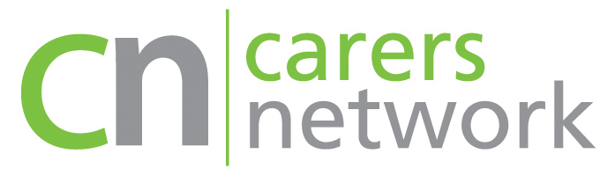

Free Online Training for Unpaid Carers

Carers Network has places available on free online training courses for adult unpaid carers looking after someone over 18 living in City of Westminster, London Borough of Hammersmith & Fulham or Royal Borough of Kensington and Chelsea.

Carers can do these online modules in own time and at own pace.

There will be 2 courses to choose from that will include interactive quizzes, videos, downloads and worksheets:

1. Caring for Carers

This online course is suitable for any unpaid carer and learners of all levels. It will enable carers to understand and recognise that it is important to look after their own health and wellbeing.

2. Dementia Carers training

This online course is suitable for unpaid carers who are looking after a person with dementia and wish to learn more about the condition and how to manage their care.

The course is designed to help carers find new ways to build resilience so they can survive and grow.

Carers can register for either or both of these courses directly by emailing events@carers-network.org.uk or calling 020 8960 3033 / professional referrals on behalf of clients for the courses can also be received via this email address.

