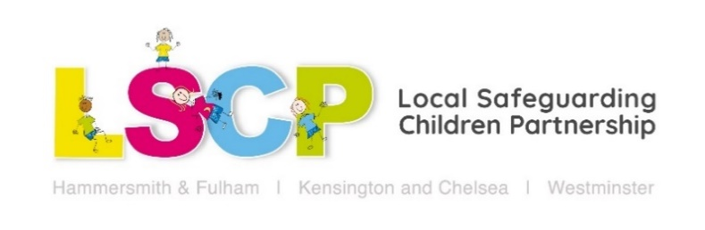
What to do when you’re worried about a child or young person
Friday 5th February 2021 9.30am – 11.30am
A short virtual workshop that will support community organisations to feel confident in making referrals to children’s services, discussing their concerns with families and social workers, and clarify how to refer to Hammersmith and Fulham, Kensington and Chelsea and Westminster. Please come along with anonymised case studies, examples of safeguarding dilemmas you have had and feedback on your experience of making referrals if you have done so. We want the session to be as interactive and helpful as possible.

Learning Objectives:
- To understand what information is needed to make a good referral
- Have the opportunity to share safeguarding dilemmas and ask questions
- Have the opportunity to practise sharing concerns with social workers and families
- An improved understanding of how to refer to the three boroughs and what happens when a referral is made
- An improved understanding of children’s services thresholds and when we need agreement from families to work with us

Agenda:
9.30 – 9.45: Introductions
9.45 – 10.00: Why it’s important to share concerns with families
10.00 – 10.55: What makes a good referral & how to share concerns with families
10.55 – 11.15: How to refer to the three boroughs & what the MASH team do
11.15 – 11.30: Questions, comments & feedback

To book a place via Eventbrite please go to: https://whattodoifworriedaboutachild.eventbrite.co.uk
For all LSCP Training events please visit: www.rbkc.gov.uk/lscb/training-and-resources

