Dawes Road Hub, Office 1
Suitable for up to eight users
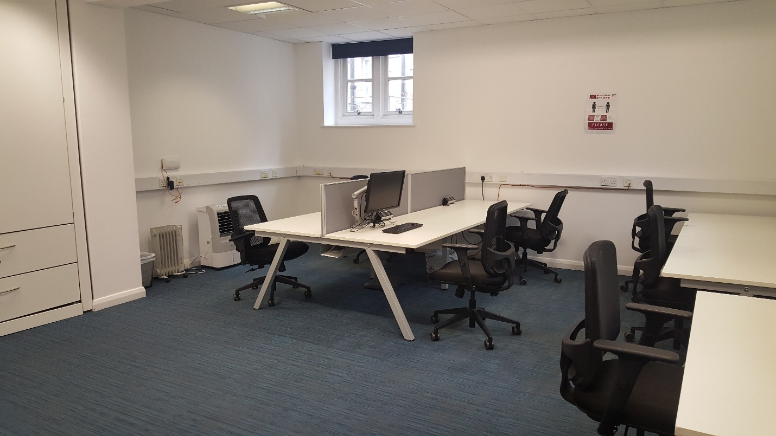
Includes large storage space and meet and greet area
