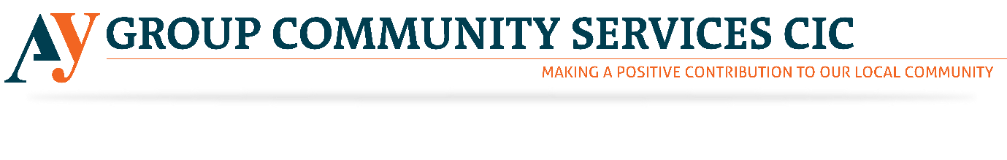

Outreach Volunteer
AY Group is currently hiring Outreach Volunteers for its community service organisation. Please see below to find the detailed information regarding the roles mentioned above. With increasing Knife crime, AY Group has started selling First Aid Courses to train the people to stay safe. Please revert us if the above-mentioned opportunity excites you. However, through this noble job, you will get a chance to give something back to the society. Our society needs your hearty support. Please come and join us to this noble venture.

About AY Group CIC
AY Group CIC aims to offer a facility that will provide social, educational, recreational and wellbeing activities in a safe and secure community environment. We will also promote community cohesion through dialogue and discussions at the centre where all groups from diverse backgrounds will be welcome.
Who are we looking for?
The role of the outreach volunteer is to promote the work of AY Group CIC to potential clients and stakeholders by engaging with the local community using a variety of methods enabling AY Group CIC to meet its overall target of making a positive contribution to our local community.

Tasks
- Research and engage with the local community to identify what their needs are
- Develop key contacts with relevant stakeholders
- Encourage the local community to register with AY Group CIC.
- Arrange outreach sessions using a variety of methods
- Inform clients about the services AY Group CIC offers
- Follow up on outreach session as required

Skills and qualifications required
While no formal qualifications are required we would like volunteers to have the following skills:-
- Organisational skills
- Public speaking skills
- Good communication skills both written and spoken
- Experience of engaging with the public and being able to relate to people of different ages
- Understanding of cultural diversity and access issues
- Good networking skills
- Innovation and the ability to develop resources
- Good timekeeping

Commitment required
The volunteer will need to be able to attend two to three outreach sessions per week arranged in advance. We need a volunteer to commit to at least three months.

Induction and Training
Volunteers will receive a full induction into the organisation and training which is relevant to the role of an AY Group CIC outreach volunteer.

Support and supervision
All volunteers will be offered ongoing support by the CEO of AY Group CIC.

Recruitment process
Volunteers will need to complete an application form before being invited for an informal discussion with the Director and the CEO.

Screening
Volunteers are asked to provide details of two referees on their application form. For volunteers who are unable to provide this information a trial period will be arranged.

Benefits to the volunteer
- Gain experience in a third sector organisation
- Develop transferable skills or enhance your existing skills
- A reference for volunteers seeking paid employment. Volunteers must commit to at least three months of volunteering first.

