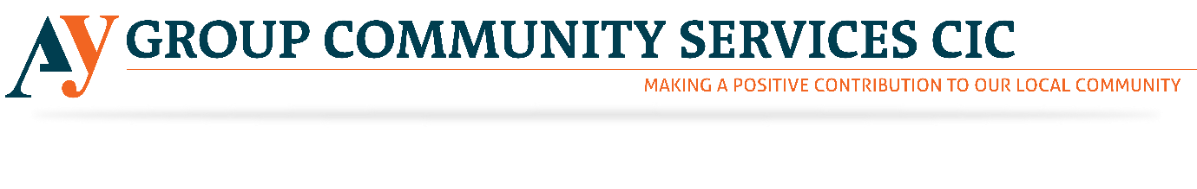
Marketing Volunteer
AY Group is currently hiring Marketing Volunteers for its community service organisation. Please see below to find the detailed information regarding the roles mentioned above. With increasing Knife crime, AY Group has started selling First Aid Courses to train the people to stay safe. Please revert us if the above-mentioned opportunity excites you. However, through this noble job, you will get a chance to give something back to the society. Our society needs your hearty support. Please come and join us to this noble venture.

About AY Group CIC
AY Group CIC aims to offer a facility that will provide social, educational, recreational and wellbeing activities in a safe and secure community environment. We will also promote community cohesion through dialogue and discussions at the centre where all groups from diverse backgrounds will be welcome.
Who are we looking for?
The role of the Marketing volunteer is to promote the work of AY Group CIC to potential clients and stakeholders by developing and overseeing marketing campaigns.

Tasks
- Overseeing and developing marketing campaigns
- Conducting research and analysing data to identify and define audiences
- Developing a social media presence for AY Group CIC using all of the main platforms e.g. Twitter, Facebook and Instagram
- Keeping our social media channels updated on a regular basis
- Encouraging others to comment on and share AY Groups social media posts
- Developing promotional activities and events to engage with key stakeholders
- Writing and proofreading creative copy
- Ensuring information on databases is correct and useful

Skills and qualifications required
While no formal qualifications are required we would like volunteers to have the following skills:-
- Some experience of marketing and social media, either through education, work or volunteering
- Good communication skills both written and spoken
- Familiar with using social media and other online tools to generate interest in a business or project
- An excellent communicator
- Aware of the latest trends relating to marketing and social media
- Able to write clearly, accurately and succinctly
- Good networking skills
- Innovative with the ability to develop resources
- Reliable with good timekeeping

Commitment required
The volunteer will need to be able to attend one of our offices (either Fulham or Tower Hamlets) up to three times per week arranged in advance. We need a volunteer to commit to at least three months.

Induction and Training
Volunteers will receive a full induction into the organisation and training which is relevant to the role of an AY Group CIC Marketing volunteer.

Support and supervision
All volunteers will be offered ongoing support by the CEO of AY Group CIC.

Recruitment process
Volunteers will need to complete an application form before being invited for an informal discussion with the Director and the CEO.

Screening
Volunteers are asked to provide details of two referees on their application form. For volunteers who are unable to provide this information a trial period will be arranged.

Benefits to the volunteer
- Gain experience in a third sector organisation
- Develop transferable skills or enhance your existing skills
- A reference for volunteers seeking paid employment. Volunteers must commit to at least three months of volunteering first.

