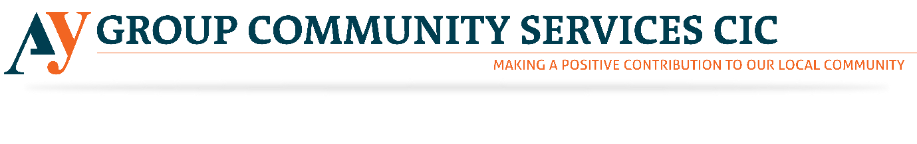Role Details
Title Fashion Designer Volunteer
Organisation AY Group

Description
AY Group is currently hiring Fashion Volunteer for its community service organisation. Please see below to find the detailed information regarding the roles mentioned above. We are looking to bring together a small team of fashion designers to develop our new fashion brand, EYSIAT, an online fashion store. Proceeds raised from EYSIAT are invested back into our work to support young disadvantaged people to find employment. Please revert us if the above-mentioned opportunity excites you. However, through this noble job, you will get a chance to give something back to the society and grow professionally. Our society needs your hearty support. Please come and join us to this noble venture.

Volunteering Role

Post Title: Fashion Designer

Department: Fundraising

Contract: 12 months fixed term/2 weeks’ notice must be given

Hours:

Location: London Office

Responsible to: CEO (Danny Barnes)

The main area of work for the fashion designer we are looking for is high street fashion and mass manufactured garments. You will research buying patterns, seasonal trends and celebrity catwalk influences which play a key role in the design process. It is a commercial area and heavily media led.
As part of a small team, you will be:
• creating/visualising an idea and producing a design by hand or using computer-aided design (CAD);
• keeping up to date with emerging fashion trends as well as general trends relating to fabrics, colours and shapes;
• planning and developing ranges;
• working with others in the design team, such as buyers and forecasters, to develop products to meet a brief;
• liaising closely with sales, buying and production teams on an ongoing basis to ensure the item suits the customer, market and price points;
• understanding design from a technical perspective, i.e. producing patterns, toiles and technical specifications for designs;
• adapting existing designs for mass production.
We ask that you can spare a minimum of two days per week for at least 3 months. We can be flexible to suit your availability (e.g. studies, childcare).
If you stay with us, you may have the chance to progress to other volunteer or paid roles, although this is not guaranteed.
You will be required to undertake a basic criminal record disclosure check for this role.

Role Address
Chrisp Street Exchange 12 Vesey Path London
Postcode
E14 6BT

Directions
DLR: All Saints

Notice Period
One week
One off volunteer role
For Individuals
For Groups
Number of volunteers required
4
Skills Required
Creative & Design

Skills Description
This role is ideal for recent fashion graduates. • Creating/visualising an idea and producing a design by hand or using computer-aided design (CAD); • keeping up to date with emerging fashion trends as well as general trends relating to fabrics, colours and shapes; • planning and developing ranges; • basic knowledge of Photoshop, Illustrator, CorelDraw; • understanding design from a technical perspective, i.e. producing patterns and technical specifications for designs.

Benefits from this role
• Gain valuable skills and experience • Be part of a friendly team • Contribute to the success of a not-for-profit enterprise.

Age Ranges
18 and over

Activities
Retail & Charity Shops,Art & Design

Application Form
DBS Criminal Record Check
References
Informal Discussion (may include an interview)
We welcome and/or have the resources to support:We Welcome Applicants applying for this role must be aged 18 over.

When we need you to do this role
The role takes place at these times
 | Morning | Afternoon | Evening
Monday
Tuesday
Wednesday
Thursday
Friday
Saturday
Sunday

