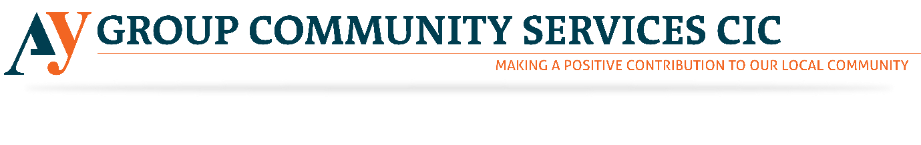

Admin Volunteer
AY Group is currently hiring Admin Volunteers for its community service organisation. Please see below to find the detailed information regarding the roles mentioned above. With increasing Knife crime, AY Group has started selling First Aid Courses to train the people to stay safe. Please revert us if the above-mentioned opportunity excites you. However, through this noble job, you will get a chance to give something back to the society. Our society needs your hearty support. Please come and join us to this noble venture.

About AY Group CIC
AY Group CIC aims to offer a facility that will provide social, educational, recreational and wellbeing activities in a safe and secure community environment. We will also promote community cohesion through dialogue and discussions at the centre where all groups from diverse backgrounds will be welcome.
Who are we looking for?
The role of the admin volunteer is to provide administrative support to the staff of AY Group CIC. Working in a small office you will be the first point of call for people wishing to find out more about the activities of AY Group CIC.

Tasks
- To provide a reception service, welcoming visitors, identifying the reason for their visit and notifying the relevant person as necessary
- Setting up administrative systems including computerised and manual filing systems
- Answering phone calls and directing them to the relevant person
- Ensuring that messages are logged and passed on as appropriate
- Keeping a record of all visitors and ensuring that they sign in and out of the building
- Collecting mail and distributing to the relevant person
- Providing information on AY Groups activities as and when required
- General admin tasks including typing documents, filing, photocopying and data entry
- Arranging meetings and taking minutes as required
- To participate in training and team meetings as required

Skills and qualifications required
While no formal qualifications are required, we would like volunteers to have the following skills:-
- A self-starter who is able to work with minimal supervision, using their initiative to complete tasks
- Organisational skills
- Strong Administrative skills including IT skills and data entry
- Proficient in Microsoft Office in particular Word and Excel
- Good communication skills both written and spoken
- Innovation and the ability to develop resources
- Good timekeeping

Commitment required
The volunteer will need to be able to attend AY Group CIC two to three times per week to be arranged in advance. We need a volunteer to commit to at least three months.

Induction and Training
Volunteers will receive a full induction into AY Group CIC and training relevant to the role of an administrative worker.

Support and supervision
All volunteers will be offered ongoing support by the CEO of AY Group CIC.

Recruitment process
Volunteers will need to complete an application form before being invited for an informal discussion with the Director and the CEO.

Screening
Volunteers are asked to provide details of two referees on their application form. Volunteers who are unable to provide this information will be offered a trial period.

Benefits to the volunteer
- Gain experience in a third sector organisation
- Develop transferable skills or enhance your existing skills
- A reference for volunteers seeking paid employment
- Continued support with your professional development from AY Group CIC staff members and trustees.

.

