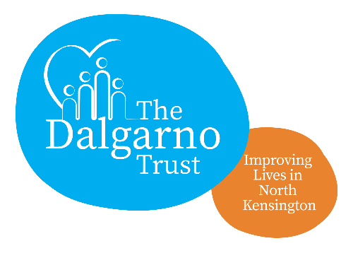

VIP (Volunteers in Partnership) Project

Overview for applicants for post of VIP Co-ordinator

The VIP Project seeks to reduce social isolation and loneliness by bringing people together at the Dalgarno Community Centre. We offer a warm, safe, friendly and secure environment where people feel included and valued. We run a wide variety of different activities that we can encourage people to join in on. These include: yoga, Zumba, book break, community kitchen, arts and crafts and self-empowerment workshops.

The VIP Project wants to reach the following groups:
- Older people living alone
- People living with mental health issues
- Young people
- People living with disabilities
- People whose first language isn’t English.

The VIP Project wants to have:
- A positive impact on the lives of isolated and lonely people across our borough
- Increased access for those who are lonely
- Improved physical, mental and emotional health for vulnerable people
- Improved social cohesion and social integration
- Help local people feel closer to others and become part of a meaningful social network
- Collaborations or joint working between community partners and groups across generations.

The VIP Co-ordinator will oversee this project and recruit volunteers to help support the project. This person will also liaise with a range of agencies such as ADKC, Barlby Doctors’ Surgery, Carers’ Network as well as tenants’ and residents’ associations in the area.

The VIP Co-ordinator will be responsible for the administration of the project. This involves development master plans, completing health and safety risk assessments. Collecting feedback from service users is an essential part of the job as quarterly monitoring reports have to be done.

The VIP Co-ordinator will benefit from training in the role by the previous post holder.

