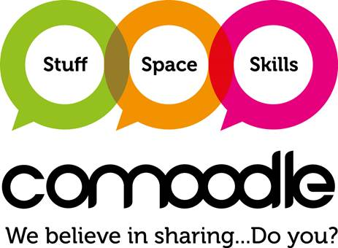

**What is Comoodle?**

Comoodle is a programme that’s all about sharing stuff, skills and space to support great community projects. We are pleased to say it will soon be available to the people of Hammersmith & Fulham as the programme has been funded by Mayor of London and LBHF.

**How it works**

* You make available whatever you like via the website
* You have full control of the content that is yours and the terms of use
* Requests come to you
* You decide if the group asking for the items can have them.

Members can ask for any item that’s on Comoodle. If what you want isn’t there, you can post on the message boards. People can offer things for free. You can ask for a donation or charge set fees if you are a not-for-profit business or charity.

**Why would I use Comoodle?**

By using Comoodle you can make new connections with other people who have resources to help you, and you can help them by making your assets and skills available too. Comoodle saves money as you no longer need to buy when you can borrow and it means you can get projects of the ground much more quickly. It is great for experimenting and prototyping activity to see if it works, as you can borrow things for the short term and see if the activity is popular. You can even find people with skills to solve the problems that keep you awake at night.

**Does it work?**

The original Comoodle was started in Kirklees, West Yorkshire, creating a community of more than 850 members. Together they are sharing more than 2,000 offers of stuff, skills and space.

When you join Comoodle, you will get your own profile where you can tell people about your projects or business and you can add photos and web links. If you want to ask for expenses, deposits or get people to sign basic agreements that’s all up to you.

To date Comoodle have had no formal complaints and only a few minor issues with late returns or items getting damaged. At the end of the day people are human and forget, or mistakes happen but generally it has been found that people respect each other and look after things and make new connections.

**How will it be rolled out in Hammersmith & Fulham?**

If we want to make this work in Hammersmith & Fulham we have to start with the offers of resources. No one can borrow or request anything until it’s offered up. So from now till early September we want to get local people and organisations to get Comoodling: to have a great listing of offers of stuff, space and skills and to get some great stories of what people have done to share with others.

So: have you got sports equipment others could borrow? Or equipment for cooking healthy food? We need spaces for people to get active or learn how to live healthy lives and we need people with skills to share too.

**How do I get involved?**

The Comoodle H&F home page will be live soon, but in the meantime, contact to get started, or just to chat to see what stuff, space or skills you might be able to share.

**We are right at the beginning of this in Hammersmith & Fulham and you could join us to make it fly.**

**The H&F Comoodle Challenge**

1. Can you sign up to Comoodle and then get others to do the same?
2. Can you hunt down some great resources in H&F and add them to your “shares”?

* We need some great sharing stories from Hammersmith & Fulham – do you have any? We would love to feature your work in a Comoodle blog
* Do you run events that have other community projects and leaders at? We would be happy to attend and speak, or have a stall
* Do you have any publications that we can feature in – we would like to send you an article when we go fully public later in the year.

**If you need to know more, just get in touch**

[comoodle@sobus.org.uk](mailto:comoodle@sobus.org.uk)