Join H&F’s CommUNITY Day in Ravenscourt Park on Sunday 21st July with HF ArtsFest

CALL OUT FOR COMMUNITY AND VOLUNTARY GROUPS
CommUNITY Day is unique celebration event bringing together members of all different communities in the borough to enjoy an afternoon of performances and activities for all the family. HF ArtsFest are looking for interested groups who would like to offer information about their activities by running a stall and/or providing tasters of their work.
The event attracted around 4000 people over the course of the day last year so it is a great opportunity to promote your activities and connect with local residents.
Date: Sunday 21st July
Location: Ravenscourt Park, W6 0UA
Event Times: 12 – 6pm
Set up time: 10am – 12noon

Stall dimensions: 7ft wide x 3ft deep with 7 x 7ft cover
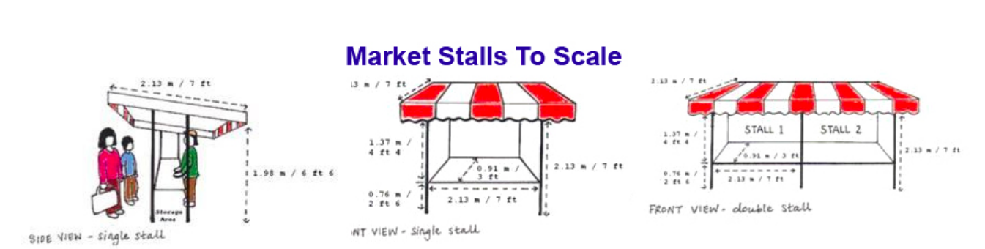

For more information and to reserve a stall please contact HF ArtsFest Producer Flora on info@hf-artsfest.com

For more info about the festival feel free to take a look at www.hf-artsfest.com

CALL OUT FOR VOLUNTEERS

CommUNITY Day is unique celebration event bringing together members of all different communities in the borough to enjoy an afternoon of performances and activities for all the family.
HF ArtsFest are looking for volunteers to support the delivery of CommUNITY Day in Ravenscourt Park on Sunday 21st July 2019. If you are a resident in H&F and passionate about contributing to your local community – this role is for you!

CommUNITY Event Support Role
- Supporting Event and Stage Managers in set up of the day
- Providing information to general public about the event and activities on offer and generally promoting a positive and inclusive atmosphere
- Supporting artists/groups who are taking part in the day (way finding etc)
- Distributing leaflets and HF ArtsFest marketing materials
- Providing general ad hoc event support to the events organisers/producers
Date: Sunday 21st July
Location: Ravenscourt Park, W6 0UA
Event Times: 12 – 6pm
Set up time: 10am – 12noon
Get out: 6 – 7pm

For more information and to express your interest please contact HF ArtsFest Producer Flora on info@hf-artsfest.com stating your interest in the role, why you’d like to be involved and whether you have any access or special requirements
For more info about the festival feel free to take a look at www.hf-artsfest.com

