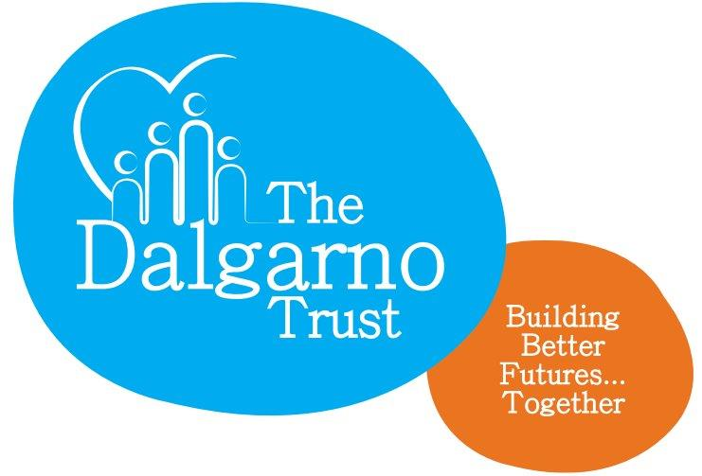

JOB DESCRIPTION

Role: | Youth Worker – 35 hours a week 3-year contract  Flexible working/job share considered
Reporting to: | Director – Marketing & Projects
Location: | 1 Webb Close, Dalgarno Way, London, W10
Salary/Pay: | £22,000-25,000 p/a (suggested)

Organisational context

The Dalgarno Trust is a dynamic local charity that works in partnership with the community, statutory, private sector and voluntary organisations to `improve the lives of everyone living in North Kensington`.

Our objectives are to:
- Enable individuals and groups of all ages and diverse backgrounds to make positive changes to their lives, fulfil their potential and break the cycles of poverty, ill-health and deprivation in the local area

- Provide a range of accessible services that offer opportunities for self-development which include access to: health awareness & improvement, education, training, employment, social and cultural opportunities

- Encourage long-term sustainability of local communities through the development of economic opportunities, support for self-funded groups and partnership work

- Create strong, inclusive, vibrant and active neighbourhoods

The purpose of this post

- To plan and lead the delivery of work with children, young people and families in the Dalgarno estates and wider community.
- To effectively monitor and evaluate the impact of the programme by creating an efficient monitoring and evaluation system that includes direct feedback from participants. This will also ensure further funding and the ability to identify good practice and the gaps to be met.
- To create and undertake youth projects, in partnership with local individuals, community groups, voluntary and statutory agencies where applicable. Outline projects will be specified on appointment.
- To line manage and encourage an effective youth team by identifying training needs, setting and monitoring targets and inspiring leadership

Key tasks

- Working with the senior youth worker, plan and deliver a programme of high quality, innovative activities (both term time and holiday) for children and young people that explore and develop their skills, encourage confidence, expand their opportunities and promote inclusive local neighbourhoods.
- Plan, develop and deliver an after school activity club and establish a girls’ youth activities programme.

- Explore and develop opportunities to work in partnership with other local youth/community organisations so expanding access to opportunities for young people

- Consulting with children, young people and the wider community to gain feedback and identify areas of need, interest and/or concern. To compile and present the results, making recommendations for improvement or development of activities to meet identified needs.

- Deliver agreed projects and outcomes in agreement with the Director of Projects and any external funders, ensuring that monitoring information and paperwork is completed efficiently and effectively

- Keep full and comprehensive records of all activities and projects undertaken and carry out monitoring and evaluation to identify whether agreed targets, outputs and outcomes have been met

- To adhere to Dalgarno’s safeguarding policies and procedures to reduce the risk of harm to children and young people.

- Attend public meetings and community days, where applicable, to engage with young people and adults to promote the programme, and to seek opportunities with local individuals

- Where applicable, draft written statistical and financial reports on specific projects as required.

- Create promotional material for projects and events.

- Where possible, negotiate for reduced rates for activities/trips and/or gifts in kind

- Able to work flexible hours as required; this will include weekly evening sessions and school holiday periods and occasional weekend days

Generic

How will the post holder know if they are performing?

A number of performance targets will be planned and agreed each year with the line manager and these will be monitored at regular meetings. Regular feedback will be provided by the line manager and opportunity provided to discuss any problems, personal and team matters and personal development issues.

Generic requirements
The post holder will be expected to comply with the Trust’s policies and procedures at all times. These include, but are not limited to equal opportunities, confidentiality, data protection and health and safety.

In order to do their job, the post holder will be expected to familiarise themselves with the Trust’s procedures and policies and to seek advice and guidance from the line manager if required.

The key tasks listed above are only an indication of the main tasks required to be performed. It is not an exhaustive list of duties and responsibilities and may be subject to amendment to take account of changing circumstances. Any changes will be made following discussion with the post holder.

Please see the person specification overleaf for use in your supporting statement

PERSON SPECIFICATION
CYF Programme Coordinator
The Person Specification states the minimum knowledge, skills and experience required to carry out the job and is used for both short listing candidates for interview and to identify the areas to explore in an interview. Please show examples of how you meet the essential criteria in your supporting statement.

E = Essential criteria; D = Desirable criteria

 |  | Criteria
1 | Experience:  - At least 2 years’ experience of working directly with children and young people  - Experience in creating, developing and delivering programmes for girls and young women  - At least 1 years’ experience in a senior position- coordinating programmes for children and young people  - Experience of planning and delivering youth and community activities/projects  - Experience of forming/managing youth forums  - Experience of marketing a project or service using concise, user-friendly printed material and other publicity for promotional purposes  - Developing monitoring and evaluation systems to ensure feedback is collected from stakeholders  - Working in a multi-cultural environment | E  E  E  E  D  D  E  E
2 | Knowledge:  - Knowledge of current, regional, local community issues and agendas  - Knowledge of methods to engage, consult and involve young people in programmes  - Knowledge of the role of community organisations in regeneration and community development  - Knowledge of the issues that face young people in inner-London; such as territoriality, policing  - Significant knowledge and understanding of safeguarding and child protection policies and procedures relating to children, young people and vulnerable adults  - Understanding of therapeutic approaches to working with children and young people  - Understanding of the developmental stages of child and adolescent development inc. attachment theory | E  E  E  D  E  D  D
3 | Skills:  - Ability to negotiate financial and in-kind contributions by external agencies to partnerships  - Ability to identify opportunities and potential partners  - Ability to work with a wide range of individuals, statutory agencies and community organisations  - Able to communicate effectively and creatively with diverse audiences, verbally and written  - Proficient in the use of outlook, word and excel | D  E  E  E  E
4 | Other:  - Willing & able to work flexible, unsociable hours including regular evenings and potential weekends  - Commitment to the organisation’s Diversity Policies | E  E

