Fulham Men’s Shed Anyone?
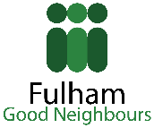
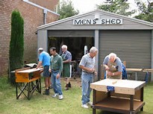
Would you be interested in setting up/or being part of a local men’s shed?
Fulham Good Neighbours would be happy to become a host and support organisation to a group of local men (and women) who might be interested in coming together to create a meeting place, where ‘Shedders’ can engage in wood work or other activity, or simply in putting the world to rights over a cup of tea.
We are calling an Information Meeting on Tuesday, 26th September 2017 at 6PM Please come along with your mates who might be interested in taking part and bring your ideas on getting the group going to:
Fulham Good Neighbours
Rosaline Hall
70 Rosaline Road
London, SW6 7QT
Tel. 020 7385 8850
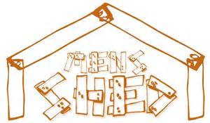
Email: info@fulhamgoodneighbours.org
Guest speaker: Mike Jenn, Chair of the Camden Town Shed

