

**Mrs Bennet’s**

**Ballroom**

**Regency Dance Classes**

*Celebrate the 200th Anniversary of Jane Austen and her love of dance.   
Can we persuade YOU to join us?!*

**Tuesdays in Fulham**

St Etheldreda’s Church Hall,  
528 Fulham Palace Road, London SW6 6DS

**Time: 7.30pm – 9.30pm**

|  |
| --- |
| **Dates:** May 23 June 6 June 20 |
| Check website for further dates |

**Summer costume stroll at Fulham Palace on 4th June!**

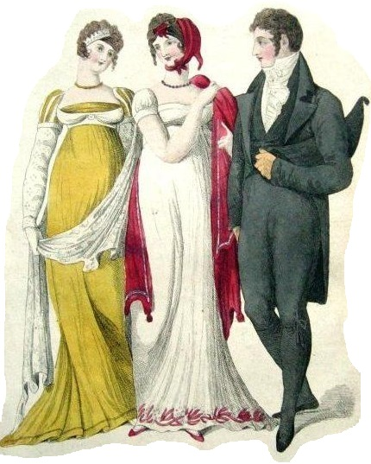

***As Jane said  
“To be fond   
of dancing is   
a certain step   
 towards falling   
 in love”!***

***We must   
make haste  
to the dance class!***

!

**Entry £7  
per class  
tea included**

www.MrsBennet.co.uk

**Contact:  
Libby  
mrsbennetsballroom@gmail.com**

[](http://www.google.co.uk/url?sa=i&source=images&cd=&cad=rja&docid=orgF3RxsYmTYbM&tbnid=4UL8Azf5OEkT8M:&ved=0CAgQjRwwAA&url=http://newsroom.fb.com/Photos-and-B-Roll/4406/Logo&ei=e8gyUvHxN8Le7Abw8YHACg&psig=AFQjCNEsp7rE8mtYQd7zfMmx4QBW6ASA2Q&ust=1379146236017988)MrsBennetsBallroom 020 8391 1215



**Mrs Bennet’s**

**Ballroom**

**Regency Dance Classes**

*Celebrate the 200th Anniversary of Jane Austen and her love of dance.   
Can we persuade YOU to join us?!*

**Tuesdays in Fulham**

St Etheldreda’s Church Hall,  
528 Fulham Palace Road, London SW6 6DS

**Time: 7.30pm – 9.30pm**

|  |
| --- |
| **Dates:** May 23 June 6 June 20 |
| Check website for further dates |

**Summer costume stroll at Fulham Palace on 4th June!**



***As Jane said  
“To be fond   
of dancing is   
a certain step   
 towards falling   
 in love”!***

***We must   
make haste  
to the dance class!***

!

**Entry £7  
per class  
tea included**

www.MrsBennet.co.uk

**Contact:  
Libby  
mrsbennetsballroom@gmail.com**

[](http://www.google.co.uk/url?sa=i&source=images&cd=&cad=rja&docid=orgF3RxsYmTYbM&tbnid=4UL8Azf5OEkT8M:&ved=0CAgQjRwwAA&url=http://newsroom.fb.com/Photos-and-B-Roll/4406/Logo&ei=e8gyUvHxN8Le7Abw8YHACg&psig=AFQjCNEsp7rE8mtYQd7zfMmx4QBW6ASA2Q&ust=1379146236017988)MrsBennetsBallroom 020 8391 1215