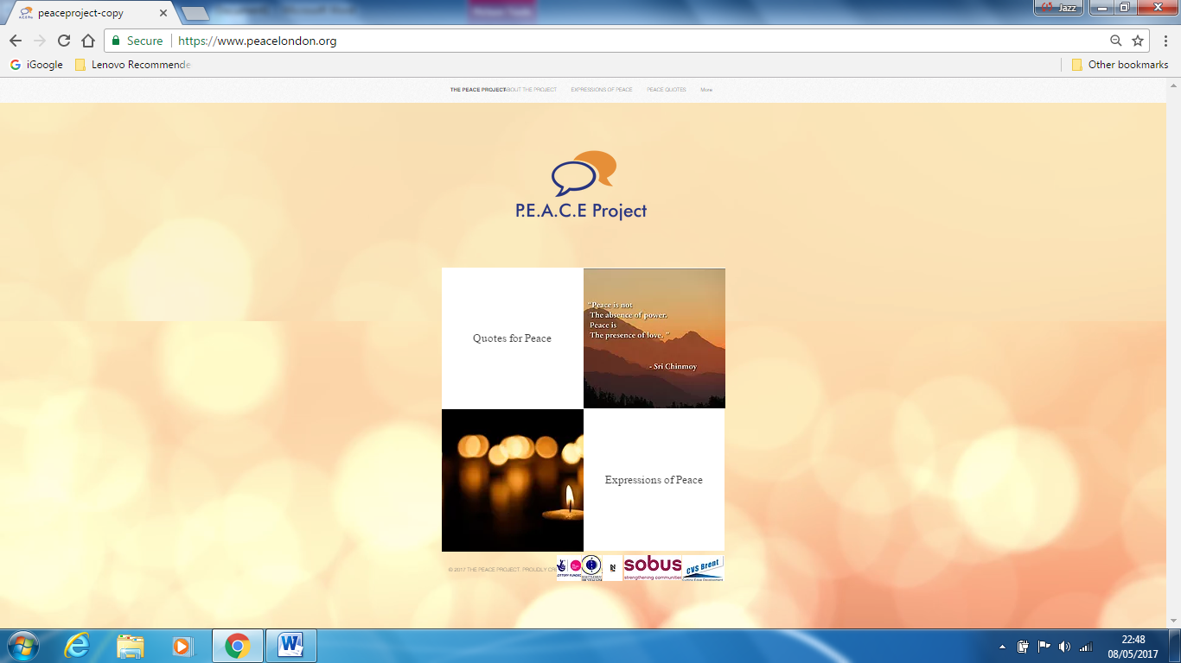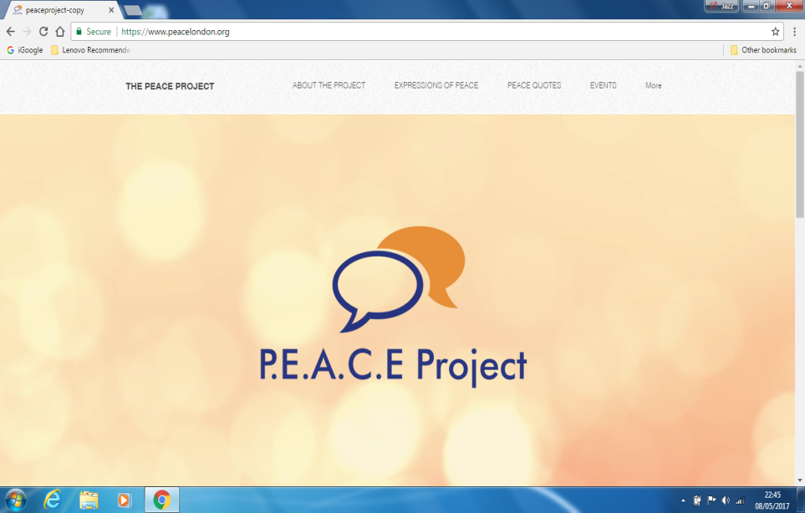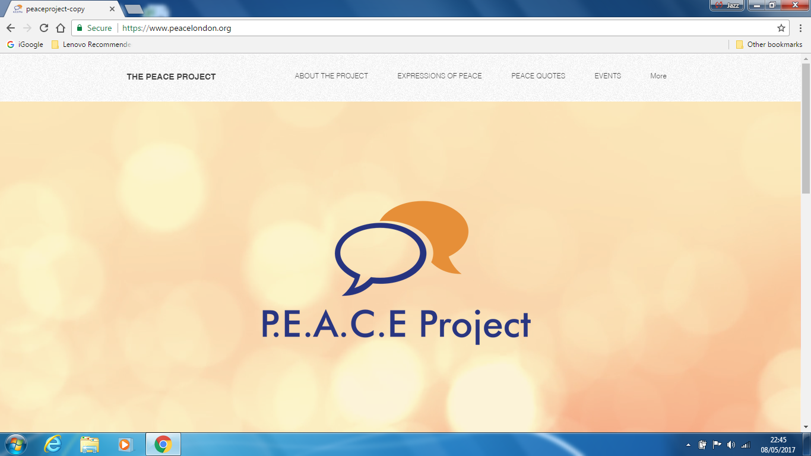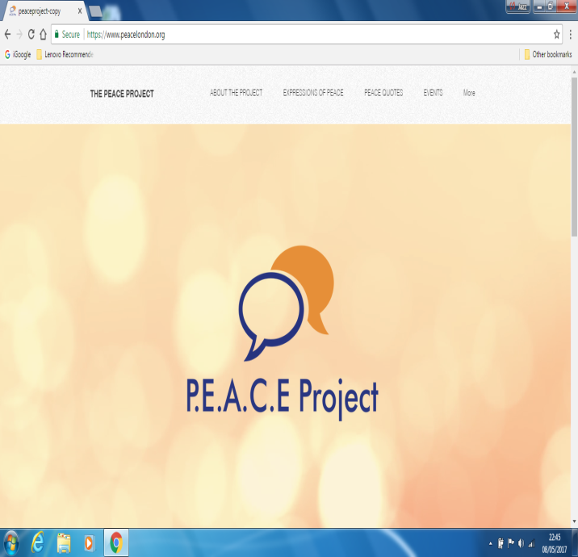

The PEACE Wall Project

Is a collection of Peace Quotes & Poetry conveying the thoughts and desires of residents from the London Boroughs of Hammersmith & Fulham and Brent

We invite you to take part in our Expression of Peace Event

Hammersmith Town Hall (Small Hall)

King Street, W6 9JU

On Tuesday 13th June 2017 ~ 12-2pm

Free Entry & Refreshments Provided

RSVP: peaceproject@plias.co.uk