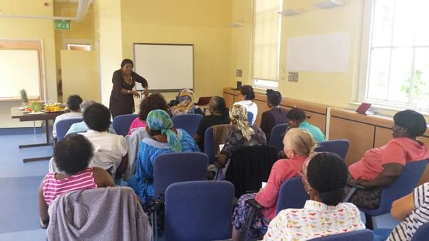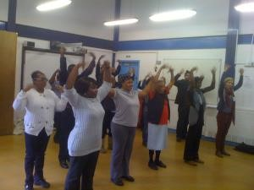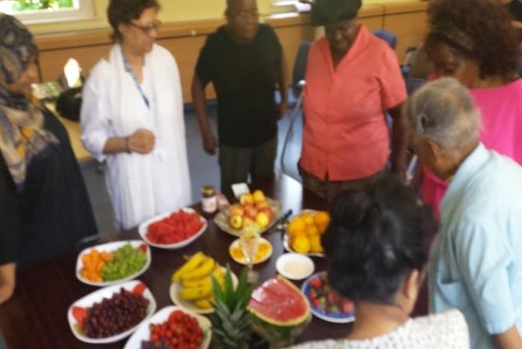

Women’s Association for Networking and Development invites you to the

**Happy Healthy Family Club**

Prom

otes Mental Health And Wellbeing

Wednesday

25

January

2017

, 10:00

–

14:00

Small Chapel, St. Charles Centre for Health

and Wellbeing

Exmoor St, London W10 6DZ

***Lunch Provided***

**Accept who you are**

**Eat Well**

**Keep Active**

**Activities Include**

●

Tai Chi session

By Royal Borough

Kensington & Chelsea Leisure Department

●

Sister Size

–

Bra

Measure

–

Breast Awareness

**●**

**“**

**Cervical Cancer Prevention Week”**

For further information please contact WAND UK on

Tel:

02089624132

or 07813485607 (Kik

i)

Email: info@wanduk.org



All Women Welcome