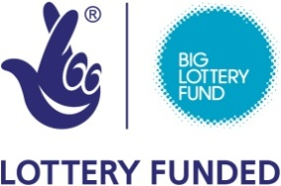
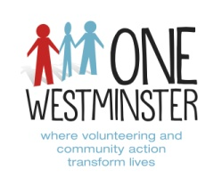

Job Advert
Family Learning Involvement Project Worker

One Westminster is looking for a new role:

Hours: Part time (17 hours per week)
Based at: Portman Early Childhood Centre, Westminster
Reports to: Family Learning Involvement Project Coordinator
Salary: The salary is £22,500 per annum (including ILW) which will be reduced pro rata per 17 hours per week. Fixed term till end March 2018

Background
One Westminster is a local charity based within three key locations in Westminster. We have a strong history and background in providing volunteer recruitment and development services, capacity building support to community organisations and front-line services. In April 2014, Voluntary Action Westminster and Volunteer Centre Westminster merged to become One Westminster and provide a range of streamlined services to beneficiaries of Westminster and beyond.

Aim of the role
FLIP (Family Learning Involvement Project) is funded by The Big Lottery Fund, Reaching Communities Programme, to deliver high quality, flexible services to parents/carers and their children (0-8 years and their siblings) by offering out of hours activities for families in the Church Street, NW8 area: after school, weekend and during school holidays, and providing a safe and rich learning environment for both children and parent/ carers. Two part-time Project Workers and volunteers support the project coordinator to develop and deliver activities and services that meet the project outcomes and enhance family learning.

How to Apply
To apply please download application pack http://www.onewestminster.org.uk/work-us
Or email Lana Al-waily lalwaily@portmancentre.co.uk
Applications close at 9am on Monday 09 January 2017 and interviews will take place on Wednesday 18 January 2017. Please note we are unable to provide feedback to unsuccessful applicants. If you have not heard from us by 16th January 2017 please assume that your application has not been shortlisted.

One Westminster
37 Chapel Street, London NW1 5DP
Switchboard: 020 7723 1216- Website: http://www.onewestminster.org.uk

Registered Charity No. 295501- Registered Company No. 205226

