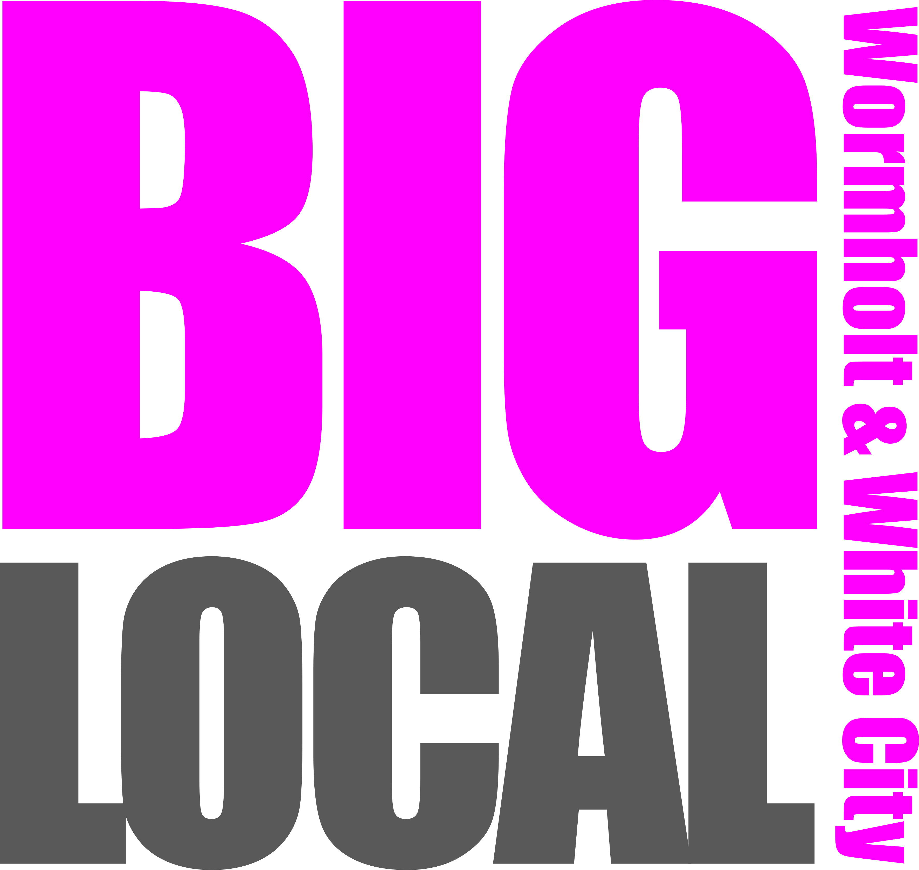


MARKETING AND COMMUNICATIONS COORDINATOR
Job Description: Events and Communications Coordinator
Hours: 22.5 hours normally to be worked over 3 days, including occasional evening and/or weekend
Salary: £28,000 pro-rata 3 days a week (£16,800) (maternity cover- up to 1 year)
Employed by: White City Enterprise
Operationally Responsible to: Big Local Manager
Responsible for: Volunteers
Main Location: White City Community Centre, India Way, W12 7QT
Background to the Role
Wormholt and White City has been selected as one of 150 neighbourhoods which are part of the Big Lottery’s “Big Local” programme, a £1 Million ten year initiative matched by Hammersmith United Charities with a further million. The programme is driven by a resident led Partnership Board which consulted extensively over a two year period and developed a strategic community plan. We are almost three years into the delivery of this 10 year plan. Based on the emerging needs and development of our Big Local Programme, it became apparent that a Marketing and Communication Coordinator is crucial in the development of the Big Local Programme and we are looking for maternity cover in this role.
Main Purpose of the Job:

To work closely with the Partnership Board and its Committees to engage the local community and to develop support from local businesses and voluntary organisations .

To undertake the responsibility for marketing and publicising the work of the overall programme using a range of marketing tools and techniques including print marketing, outreach and social media platforms.

Key Tasks:
1. Supporting the Partnership Board and each Big Local Committee with planning, promoting and delivering their events communications by:
- Working closely with the Big Local Manager and the Marketing steering group, the Marketing and Communications Coordinator will develop quarterly activity plans and promotion strategies, including outreach, print marketing and its distribution and all social media content
- Manage an annual marketing and events budget of up to £20,000.
- Ensuring a communications plan for engaging with all communities within the area is adhered to including outreach, door-to-door promotion, social media, promotional events, blogging, press releases etc.
- Updating and developing the Big Local Website and social media
- Setting up and working closely with the Big Local’s Marketing Committee, leading on event planning and delivery of 4 large annual events including the W12 Festival, including the management of this budget.
- Liaising with designers and relevant committee members to produce design briefs and order marketing supplies as requested by all Big Local sub-committee Chairs.
- Where appropriate, offer advice and support to Community Chest fund recipients in relation to marketing and promotion of their projects.
- Designing a quarterly Big Local newsletter to be distributed throughout the ward.
- Ensuring an E-newsletter, including Chairs of committees reports, is circulated to partners once every six weeks.

2. Working with Volunteers:
- Being on hand for meetings with Chair’s of Committees to discuss progress of events, activities plans and any particular marketing campaigns.
- Ensuring compliance with the organisation’s lone working, equal opportunities, health & safety and safeguarding vulnerable adults policies and procedures, including undertaking any risk assessments that may be necessary
3. Monitoring, Record Keeping & Reporting
- Maintain accurate and up-to-date records of a resident database, receiving all online communications (Newsletter database) and all Big Local event volunteers and contacts and make sure records conform with data protection law.
- Provide the necessary statistics and progress information for monitoring, etc. reports, by the required deadlines
- Provide reports as required.
5. Working with Big Local and White City Enterprise Staff:
- Liaise with all relevant staff and project’s steering groups, in relation to residents’ needs, and to develop awareness of all services available.
- Actively contribute to the potential planning and development of additional services
- Liaise and work as part of the White City Enterprise Team participating in WCE meetings and companywide events, developing working links with other projects

7. General responsibilities of post holder:
- Some meetings and other events will be held out of normal office hours, for example Sub Committee meetings or community events where the service is expected to represent Big Local/White City Enterprise.
- The above items outline the main duties and responsibilities of the post, and are designed to give an accurate flavour of the nature and scope of this post. However, they do not represent an inclusive list of all the duties required. All employees are therefore expected to work in a flexible way and if necessary to take on tasks which are not detailed in their job description.

Person Specification:
Events and Communications Coordinator (maternity cover)

The Following criteria will be assessed from information provided on your completed application form and at interview.

Criteria | Essential | Desirable
Education and Training | Strong literacy skills and a good level numeracy skills | Safeguarding Vulnerable Adults
Experience |  | -Working directly with the community  -Knowledge of Data Protection issues  -Working in a small community organisation  -Experience of Co-design (working closely with others to shape projects)  -Experience of working on programmes with an emphasis on sustainability and/or community leadership  -Coordinating community consultation and/or feedback activities
  -Coordinating community events
  -Recruiting and coordinating volunteers, particularly for events
  -Knowledge and understanding of Health & Safety issues and of risk assessment
  -Knowledge and understanding of Confidentiality issues
  -Writing Newsletters and Press releases
  -Maintaining an online platform including website and social media
  -Managing a small project budget
  -Writing project reports
Skills | -Self-directive and able to prioritise own workload  -Ability to develop positive relationships with a variety of people including professionals, potential funders, and local people from a range of different backgrounds  -Ability to deal sympathetically and sensitively with a wide range of people  -Ability to support and motivate volunteers  -competent using Publisher for design purposes  -Strong organisational skills  -Strong verbal & written communication skills  -Able to take on board constructive feedback from co-workers, local people and management and adjust approach or priorities to accommodate feedback  - Strong IT Skills, (including word and excel)  -Strong evaluation skills; able to identify gaps in programme delivery or reach of delivery, and creatively work with local people to develop initiatives to develop in areas that are lacking.  -Working with a person-centred approach | -Can use design programmes such as (Indesign, Adobe)
Other job-related requirements | -Able to work outside normal office hours when necessary on occasion.  -An interest in and awareness of the local community and a desire to learn from all local people.  -Willingness to undertake training  -Ability to separate the personal from the professional  -Able to work productively in challenging environments | Local knowledge of Wormholt and White City, or experience of working within a community oriented setting.  Knowledge of the Big Local project.

