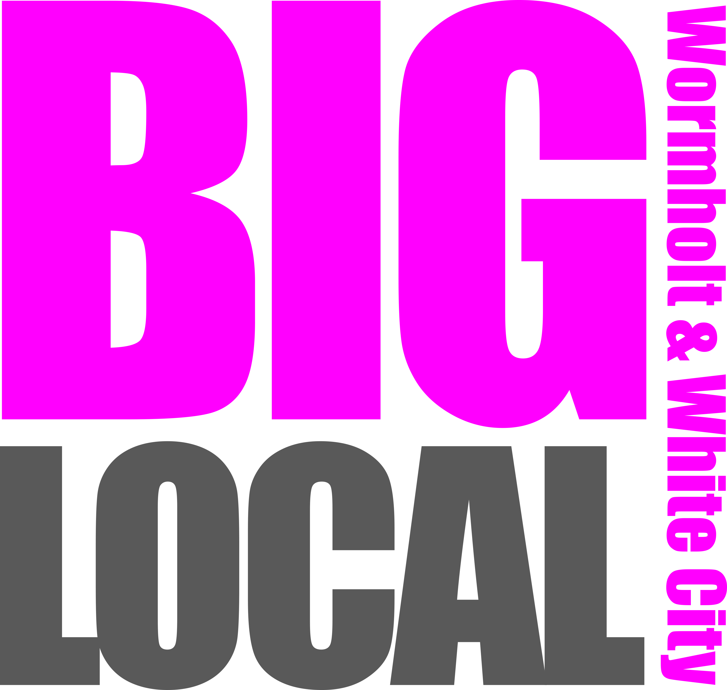

Wormholt and White City Big Local is a ten year community programme with a focus on:  
  
Developing local skills & talent through Capacity Building  
Training & Employment  
Improving the lives of Children & Families   
Providing befriending and activities for the Over 50s  
Improving levels of Community Safety

Enhancing and making the most of our Open Spaces

We are looking for an enthusiastic and passionate   
person to be part of this amazing resident led project.

**Post: Marketing & Communications Coordinator**

**Salary: £11,200**

**Hours: 16 hours per week**

**Contract: Initially fixed term until March 2016   
(with the view to extend)**

For more information or to request a recruitment pack contact Emma at [Emma@whitecityenterprise.com](mailto:Emma@whitecityenterprise.com) or on 07817 839 500

**The closing date for application submission is 5pm, Monday 14th September. Interviews will take place week commencing 21st September.**

**Job Vacancy**