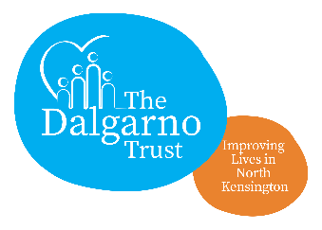

VIP Project Co-ordinator

Reporting to: HealthWorks Project Manager

Purpose: To support the day to day coordination of the VIP project as directed by the HealthWorks Project Manager.

Hours/days: 10 hours per week/days to be agreed

Salary: £13 per hour

job summary

- Helping reach local residents who may be socially isolated and lonely to overcome their situation and enjoy more within the community. Engaging with the Champions in the planning of events and activities.
- Delivering regular ongoing activities for the VIPs.
- Working with the HealthWorks Project Manager to help draft risk assessments and master plans.
- Keep track of the VIPs involvement on the Dalgarno Trust database.
- Making sure that the VIPs come together on a regular basis to meet.
- Making sure that the VIP volunteers are aware of the DBS procedure and supporting them through the process.
- Ensuring that all communications of VIPs activities – posters, leaflets and newsletters – are clear and well distributed.
- Be aware of the budgets of all activities – keeping track of costs and receipts of expenditure.
- Encouraging local people to become involved with the VIP project by making sure that all events and activities have a welcoming and friendly atmosphere.
- Observe people’s privacy under the requirements of the General Data Protection Regulation as outlined in the Dalgarno Trust Fair Processing Policy.
- Observe the Trust’s Quality, Health and Safety, Equal Opportunities Policies
- Represent the Dalgarno Trust and the VIP Project professionally and constructively at all times.
- Promote the services offered by Dalgarno Trust and partner organisations, including through other projects run by partners
- Work flexibly within the broad remit of the post, including working outside of normal office hours (Time Off in Lieu will apply) as required.
- Undertake other agreed tasks that sit within the level, grade and purpose of the post.

PERSON SPECIFICATION: VIP Project Co-ordinator

Core Competency | Essential | Desirable | Measurement Method
Self Development and Motivation  Planning and Organising  Engaging with people  Problem Solving / Decision Making  Communications  Team Work | √  √  √  √  √  √ |  | Interview  Application form  Interview  Interview  Interview  Interview

Role Specific Competency | Essential | Desirable | Measurement Method
Tact and Political Sensitivity  Excellent Listening Skills | √  √ |  | Interview  Interview

Technical Competency | Essential | Desirable | Measurement Method
IT proficiency in Microsoft Office  Experience of working in a busy office environment  Experience of office organisation & administrative procedures  Active commitment to Equal Opportunities  Training in Understanding Health Improvement  Training in Understanding Behavioural Change | √  √  √ | √  √ | Application form & interview  Application form  Application form & interview  Application form  Application form

