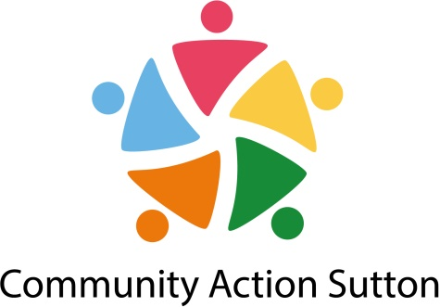
Young People’s Participation Lead
SALARY: £23,000.00 pa
HOURS: 35 hours per week including some unsociable hours (there will be some evening and weekend work for which time off in lieu will be given)
CONTRACT: 1 year fixed term contract to establish the framework
Are you interested in developing and driving forward a new approach to coordinating the voice of young people in Sutton?
Do you have experience of working with young people to support them to be heard?
Are you able to work with young people, the local voluntary and community sector and the public sector to identify the strengths and assets of young people and to decide together how to enhance the voices of young people in decision making?
Are you a motivated and dynamic individual driven by a passion for social justice?
If you have said yes to all of the above questions then this new role – Young Peoples Participation Lead in Sutton could be for you.
The purpose of this post is to work with young people and organisations in Sutton who work or support the voices of young people to develop a coordinated framework to reduce duplication and ensure that the voices of young people are heard at the local level right through to strategic decision making.
To apply for this position please see the full job description, specification and application form available on our webpage at https://www.suttoncvs.org.uk/jobs/

Unfortunately we cannot accept CV’s for this position.

The closing date for applications is 12noon on Monday 9th September 2019.

Interviews are expected to be held on Wednesday 18th September 2019

You can find out more about our organisation at wwwcommunityactionsutton.org.uk

