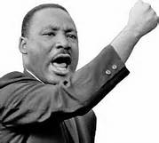
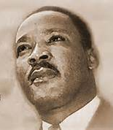
Press Release

Dream of a King

by
Christopher Tajah

A Play in One Act about the life of Martin Luther King

Time: 3rd April 1968.................Place: Memphis, Tennessee, U.S.A

Cast

Martin Luther King.......Performed by.......Christopher Tajah

Running Time: 50 Minutes Approx

We are in Martin's Motel room. Room 306 on the 2nd floor at the Lorraine Motel, Tennessee.
The date is April 3rd 1968.

On March 28th 1968, Martin led a march in Memphis that had turned in to a riot 60 people were injured and 1 young looter had been fatally shot dead by the Police. This was the first time that a march led by Martin had turned violent. Looting and bottle throwing had begun. Martin's reputation is in tatters. Days later Martin has returned to Memphis to lead another march scheduled to go ahead on April 8th 1968. Martin is blamed by the press for the lack of control of the march and for the loss of life of the young man. Martin becomes depressed, isolated and fearful of his own death? Martin's popularity has waned while groups like ' The Black Panthers ', ' Malcolm X ' and ' The Nation of Islam ' have risen to prominence.

The play will touch on some of Martin's successes, some of his weaknesses, strengths and fears.

Christopher lives in London. His acting credits include: Bottom in Mid Summer Nights Dream, Fabian in Twelfth Night, Banks in American Clock, Derek in BBC One’s Doctors. He will shortly be seen playing Baughman in The Rizen (2017 Feature) available on Netflix & VOD
For Christopher’s full CV & contact info please go to: http://www.spotlight.com/7919-0161-1817
To book Dream of a King at your venue email Christopher Tajah: tajahchristopher7@yahoo.co.uk or call him on 07960542487

